User API Testing Report

**Name: Kunal Sunil Sur  
Batch: 1 December 2024 batch of the Full Stack Development Course  
Assignment: Build a RESTful API using Node.js and Express**

**Description:  
This document includes screenshots and descriptions of each API endpoint tested using ThunderClient and MongoDB Compass.**

**Screenshot 1: GET /users**

**Description:** This test demonstrates the successful retrieval of all users stored in MongoDB. It returns an array of user objects with all user details.

*Screenshot:*

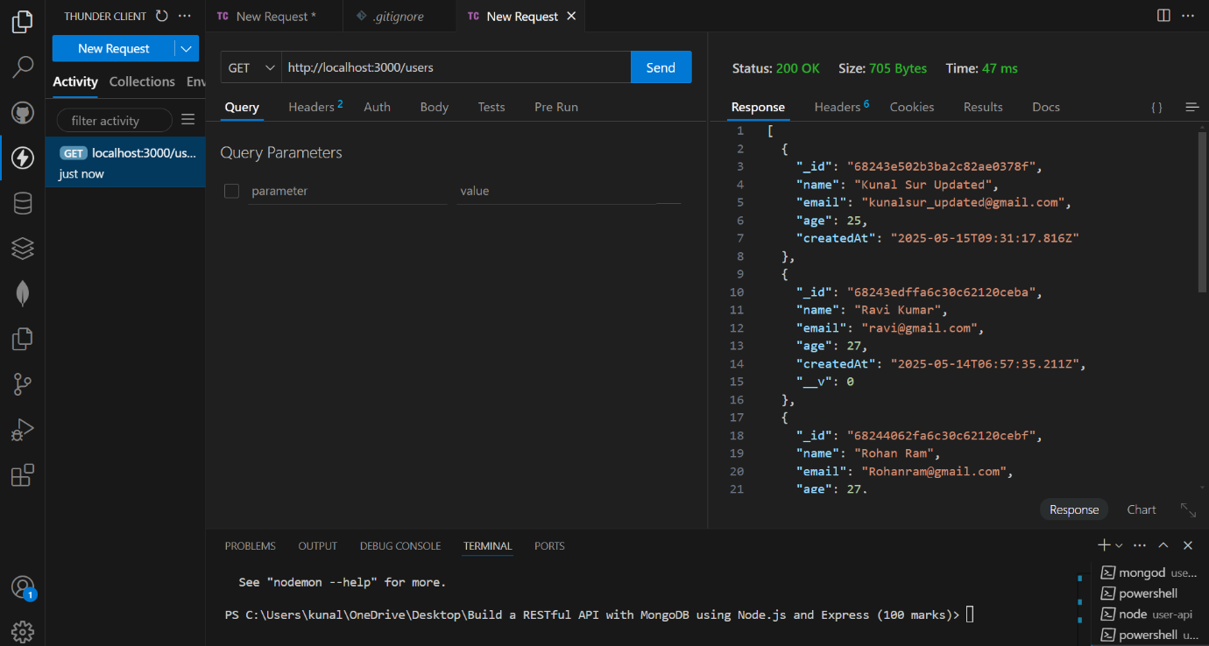

**Screenshot 2: GET /users/:id**

**Description:** This test verifies that a specific user can be retrieved using their MongoDB ObjectId. If a valid ID is provided, the correct user object is returned.

*Screenshot:*

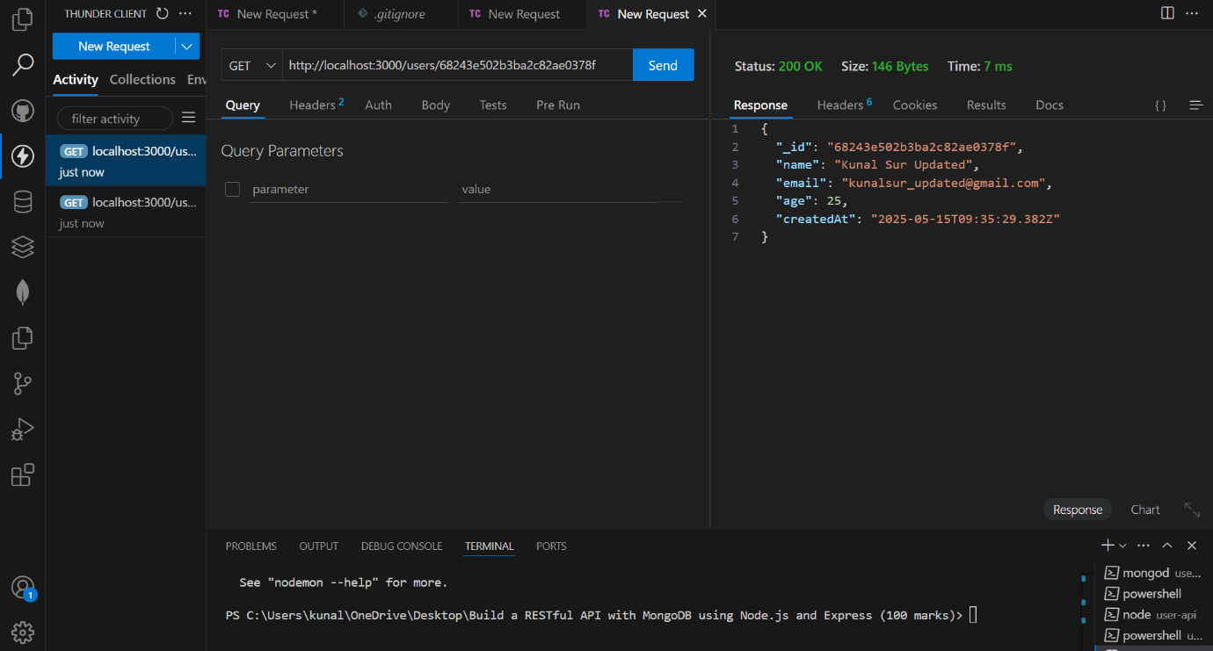

**Screenshot 3: POST /user**

**Description:** This test shows the addition of a new user to the database using a POST request. The new user data is saved and a success message is returned.

*Screenshot:*

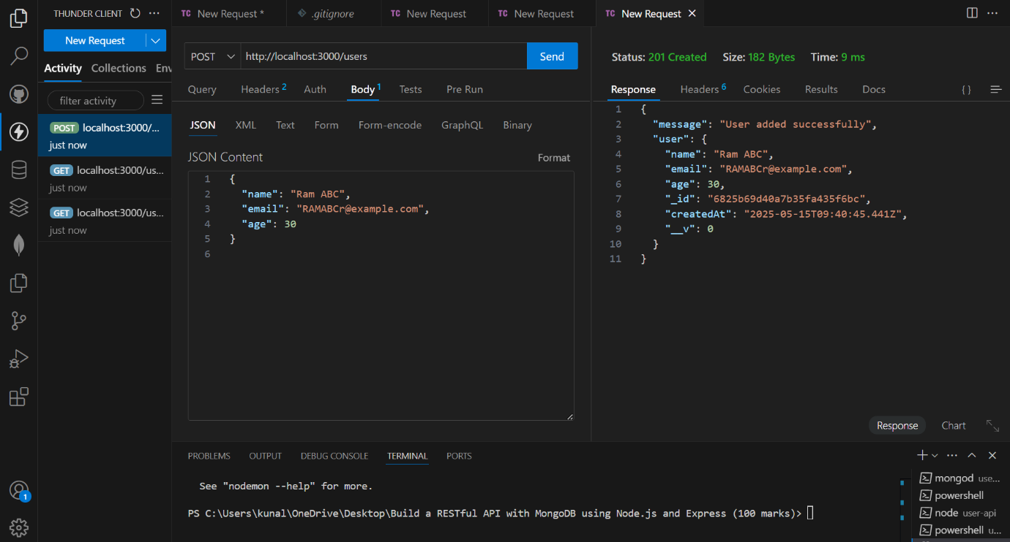

**Screenshot 4: PUT /user/:id**

**Description:** This test shows that existing user details can be updated using the PUT request. When a valid ObjectId and new data are provided, the user document is updated.

*Screenshot:*

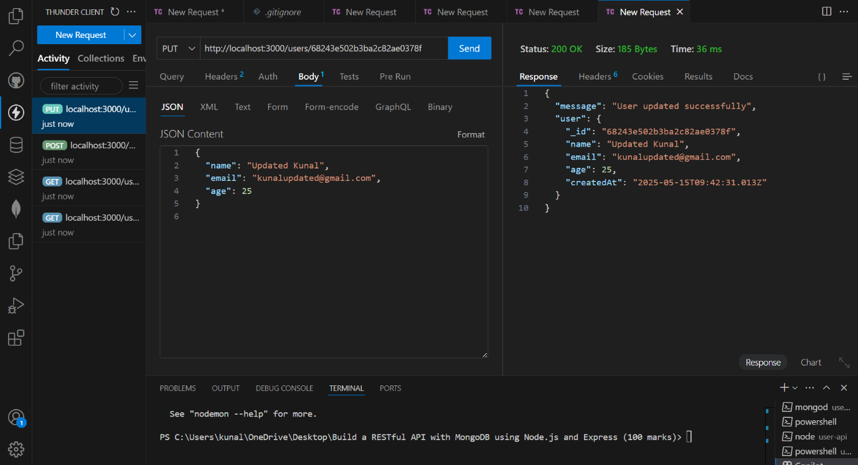

**Screenshot 5: DELETE /user/:id**

**Description:** This test demonstrates the deletion of a user from the database using their ObjectId. If the ID is valid, the user is removed successfully.

*Screenshot:*

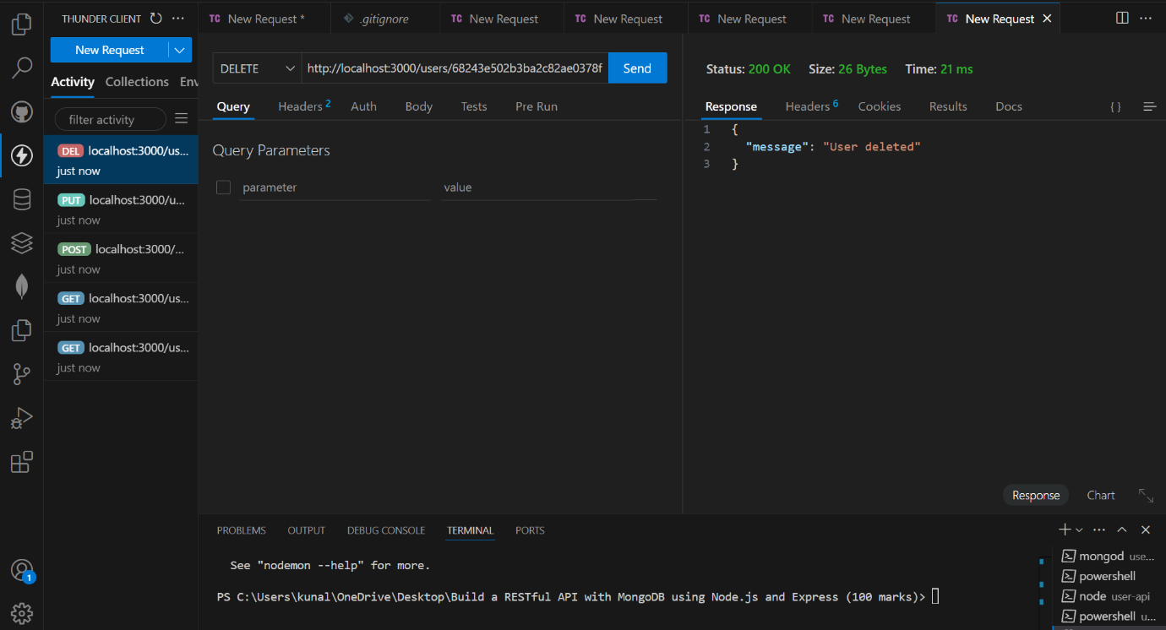

**MongoDB Compass Snapshots:**

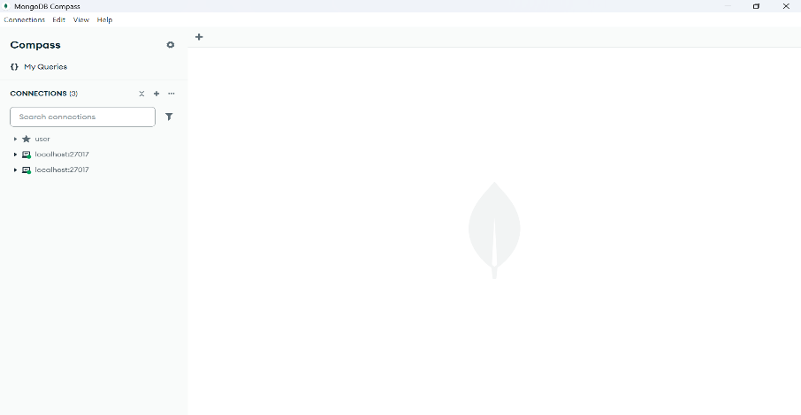

**Database List Screen:**

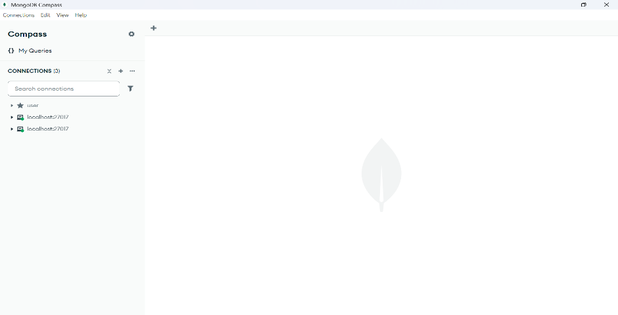

**Collection List Screen:**

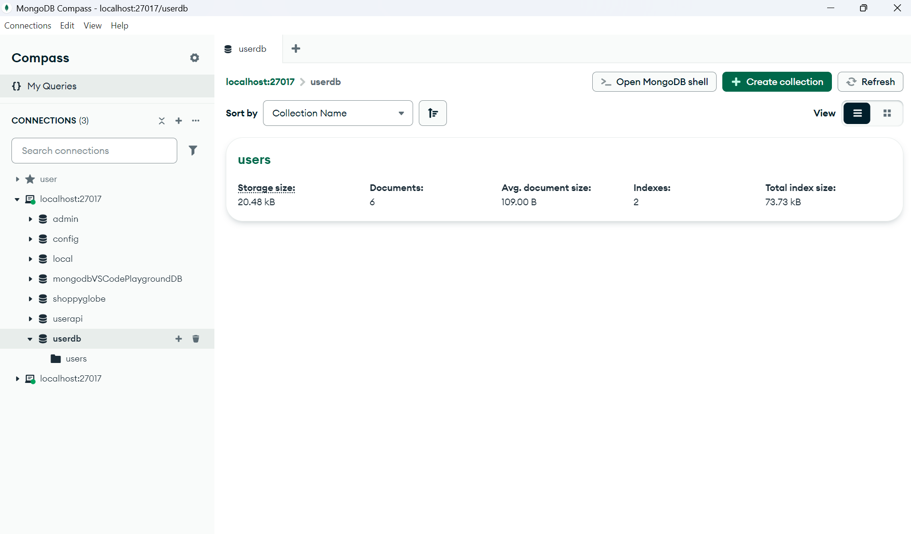

**Documents View**

